**Oakland University**

**School of Electrical & Computer Engineering**

**Winter 2023**

**ECE 4721/5721**

**Embedded System Design**

**Lab #2**

Jacob Dunn

24 February 2023

Part 1:

This experiment was to connect a speaker to the KL25Z and use the provided source code to produce a digital output through the speaker. This part required use of the KL25Z development board, a speaker, resistor, and capacitor. The speaker was connected to the GPIO on Port C pin 0. The delay in the code determines the frequency for the sound heard through the speaker and by varying that value, different sounds can be heard. The source code for this is provided in the zip file under the Part1 folder and the video demo is available in the main lab2 folder entitled Part1 Demo.

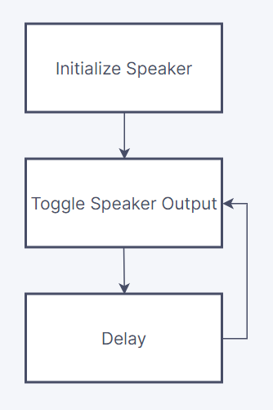

Figure 1. Flow Diagram for Speaker Output

Part 2:

This section was to implement a three state FSM to control a system involving a pump to fill a water tank. There were two sensors for this part, one to determine when the tank was empty and one to determine when the tank was full. Three LEDs were connected to this system to display the current state of the tank, green meaning there was water in the tank, yellow meaning the tank was full, and blue meaning the pump was running. The values of the empty tank sensor and the full tank sensor were controlled via a switch connected to Port B pin 8. The G, B, and Y LEDs were connected to Port E pins 3, 4, 5. These LEDs were wired through a 220Ω resistor to limit the current to the LED. The P5V_USB pin was also used to power the switch.

The source code for this is provided in the zip file under the Part2 folder and there is no video demo as this part was not fully completed. Figures 2-5 below document the hardware setup, and the flow diagram is included in figure 6 with the FSM included in figure 7.

Part 3:

The last part was to add another sensor and state to the machine, to allow the system to overflow if the water in the tank got too high. This overflow sensor turns off the pump once water begins flowing into the overflow pipe, as well as set the LEDs to represent this state. This section utilized the same hardware configuration as part 2, the only change was the addition of the extra state in the FSM and the addition of the red LED on Port E pin 2. The source code for this is provided in the zip file under the Part3 folder and there is no video demo as this part was not fully completed. The flow diagram for this section is the same as part 2 and is shown in figures 6 and 7.

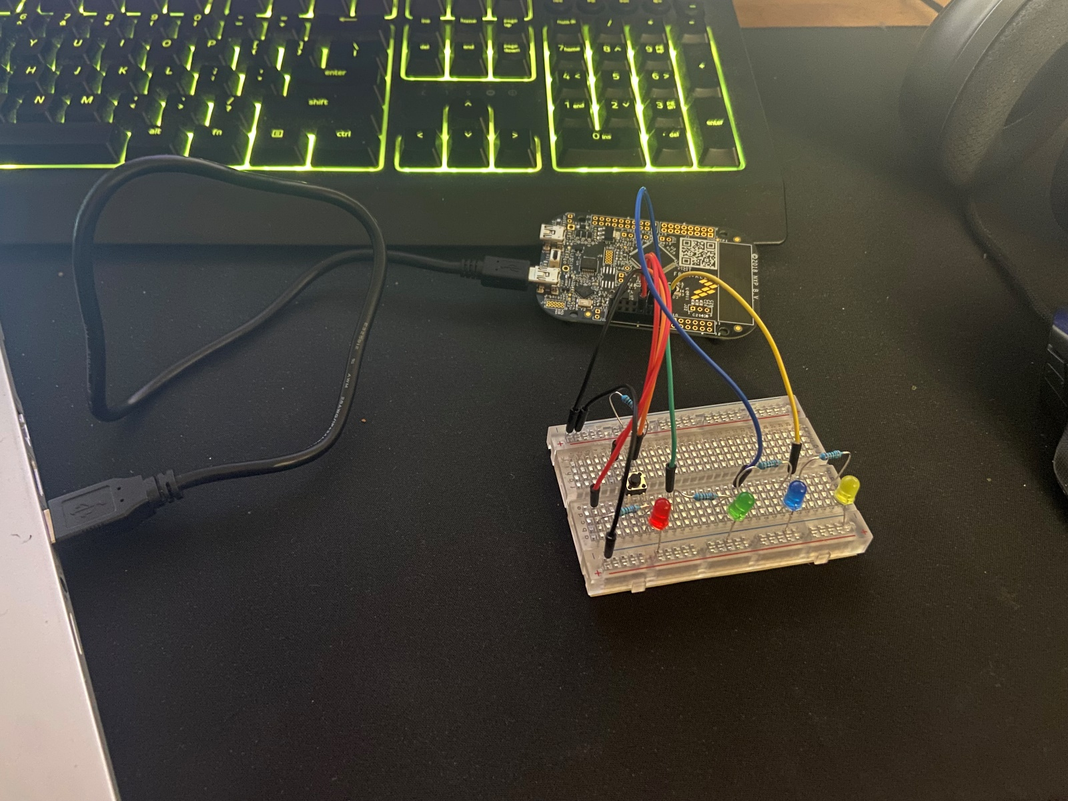

Figure 2. Full Setup

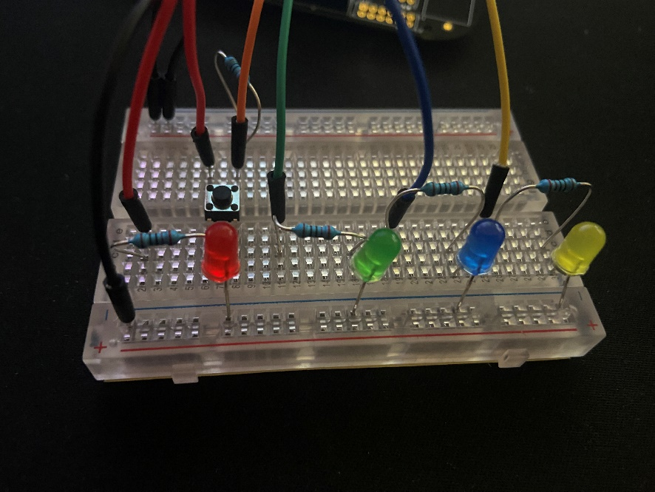

Figure 3. Breadboard Connections

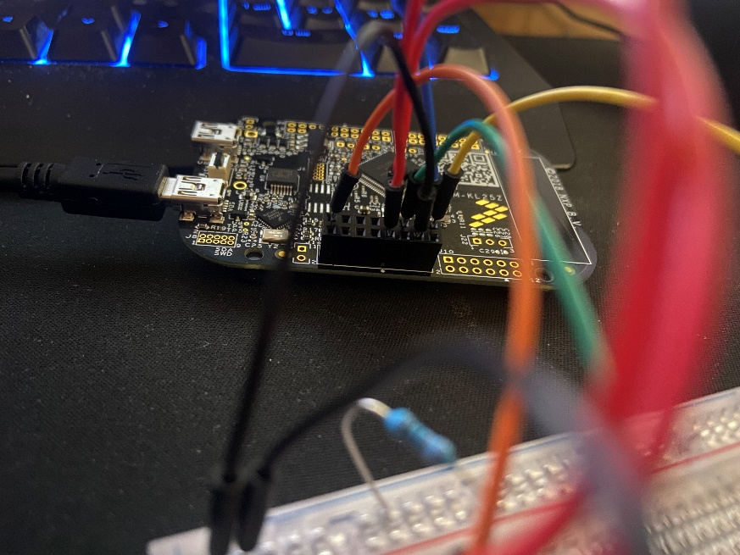

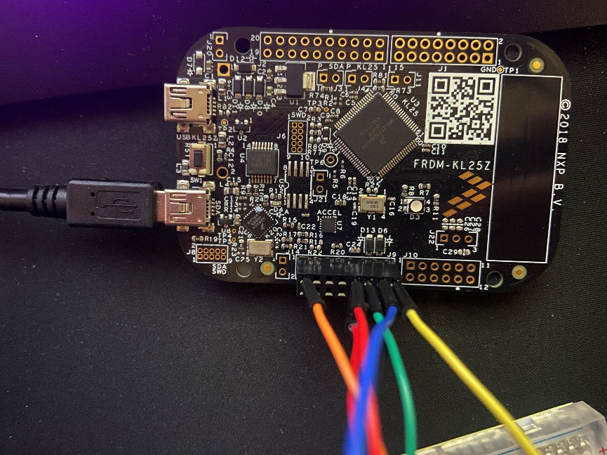Figure 4. Power and Ground Connections

Figure 5. Switch and LED Connections

Figure 6. Flow Diagram

Figure 7. FSM